Level 3

Using Sysmon and Stream

BOTSv1 3.1: MD5
In Level 2, you found the name of an executable file the attackers uploaded to the server.
Find that file's MD5 hash.
Hints:
- Read about Sysmon Event IDs
- Find events from Sysmon for process creation.
- Examine cmdline to find the correct event.
A:
Query:3791.exe EventID=1 cmdline="3791.exe"

MD5value:
AAE3F5A29935E6ABCC2C2754D12A9AF0

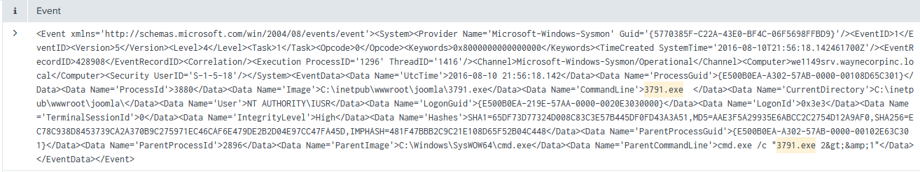

BOTSv1 3.2: Brute Force (10 pts)
What was the first brute force password used?
Hints:
- Start with 1:10 sampling.
- Find events containing "login".
- Find top values of "url".
- Examine the "form_data" values to identify the brute force attack.
A:
Query: imreallynotbatman.com http_method=POST NOT "Acunetix" http_comment="HTTP/1.1 303 See other" timestamp="2016-08-10T21:45:10.253339Z"
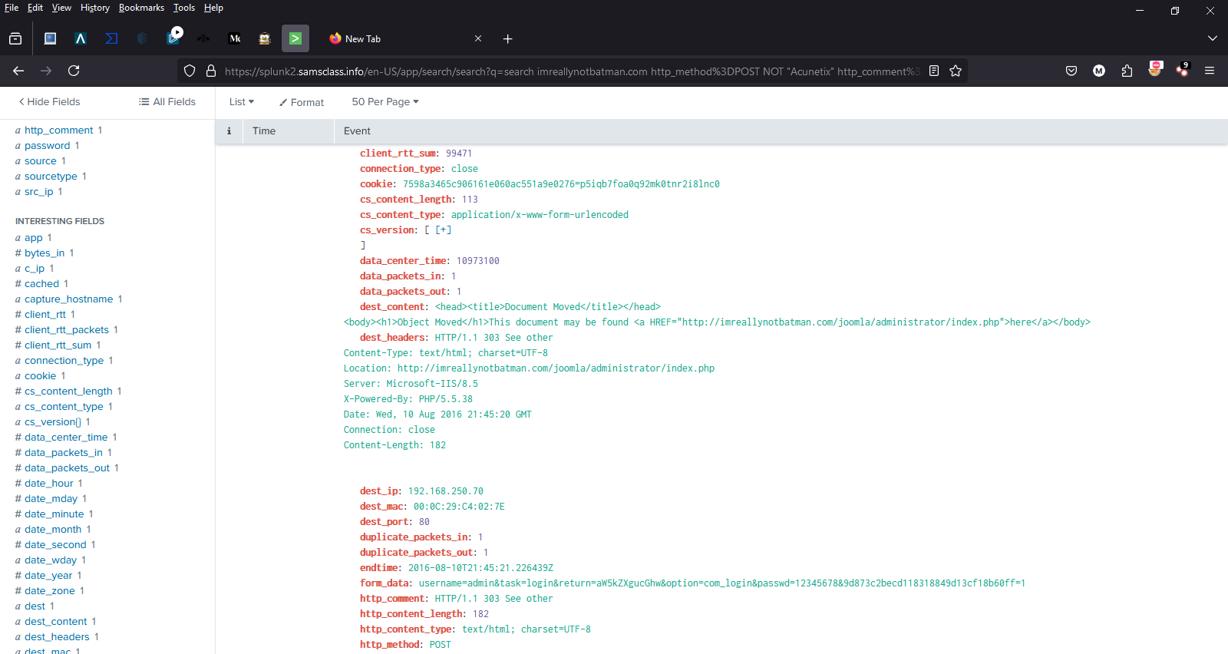
- passwd=12345678

BOTSv1 3.3: Correct Password (10 pts)
What was the correct password found in the brute force attack?
Hints:
- Find the events with the "form_data" values indicating a login attempt.
- There are two different "http_user_agent" values.
A:
Query :imreallynotbatman.com http_method=POST NOT "Acunetix" form_data="*username*passwd*"

correct password= batman

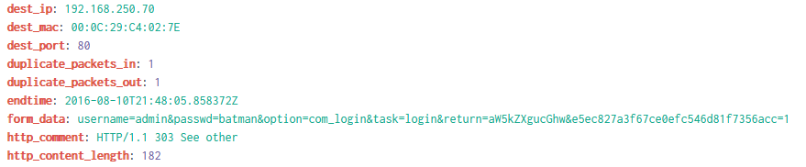

BOTSv1 3.4: Time Interval (10 pts)
How many seconds elapsed between the time the brute force password scan identified the correct password and the compromised login? Round to 2 decimal places.
Hints:
- HINT: Find the two events with the correct password in the "form_data" field.
A:
Query: index=botsv1 sourcetype=stream:http http_method=POST uri_path="/joomla/administrator/index.php"
| rex field=form_data "passwd=(?<password>\w+)"
| search password="batman"
| transaction password
| table duration
| eval rounded_duration = round(duration, 2)

- 92.17 seconds

BOTSv1 3.5: Number of Passwords (10 pts)
How many unique passwords were attempted in the brute force attack?
Hints:
- Examine http_user_agent values.

A:
Query :dest_ip="192.168.250.70" http_method=POST form_data="*username*passwd*"
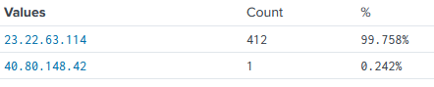
- Total 412 events all passwords are unique

